**COMPUTER ENGINEERING DEPARTMENT**

**SUBMISSION REPORT**

**SUB: Machine Learning**

**COURSE: T.E. Year: 2020-2021 Semester: VI**

**DEPT: Computer Engineering**

**SUBJECT CODE: CSDLO6021 SUBMISSION DATE: 18/05/2021**

==========================================================================================

|  |  |
| --- | --- |
| **Name: Amey Thakur** | **Roll No.: 50** |
| **Class: TE Comps B** | **ID: TU3F1819127** |

**INDEX**

|  |  |  |
| --- | --- | --- |
| **Sr.No.** | **Particulars** | **Submitted/Not Submitted or Enter Marks received** |
| **Assignments** | | |
| **1** | Assignment No. 1 | 9/10 |
| **2** | Assignment No. 2 | 9/10 |
| **3** | Assignment No. 3 | 9/10 |
| **Quizzes** | | |
| **4** | ML Quiz 1 | 10/10 |
| **5** | ML Quiz 2 | 10/10 |
| **6** | ML Quiz 3 | 10/10 |
| **7** | ML Quiz 4 | 10/10 |
| **8** | ML Quiz 5 | 10/10 |
| **9** | ML Quiz 6 | 10/10 |
| **IAT** | | |
| **10** | IAT-1 | 17/20 |
| **11** | IAT-2 | Submitted |
| **Exit Survey** | | |
| **12** | Course Exit Survey | Submitted |

**Signature:**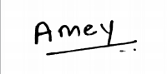

**Assignments**

**Machine Learning Assignment 1**

**Marks: (9/10)**

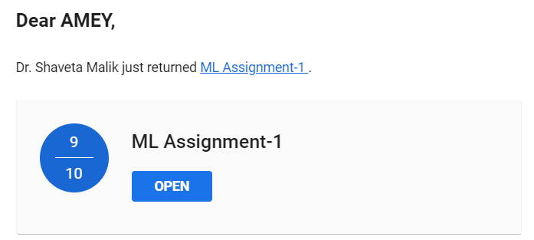

**Machine Learning Assignment 2**

**Marks: (9/10)**

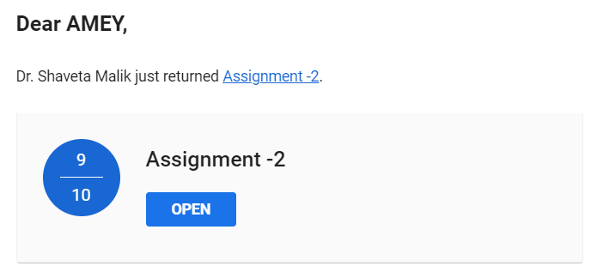

**Machine Learning Assignment 3**

**Marks: (9/10)**

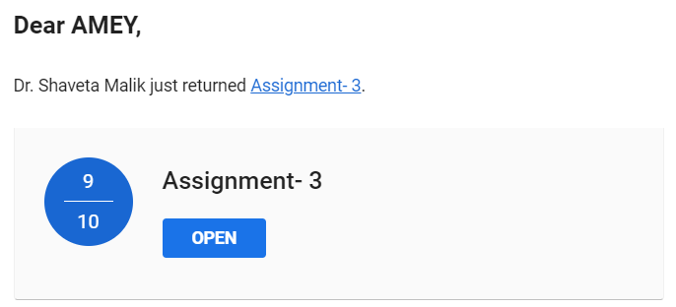

**Quizzes**

**Machine Learning Quiz 1**

**Marks: (10/10)**

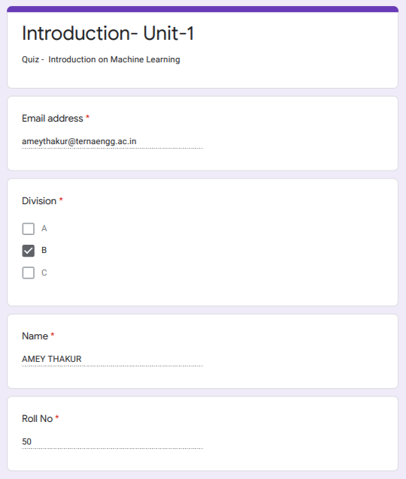

**Machine Learning Quiz 2**

**Marks: (10/10)**

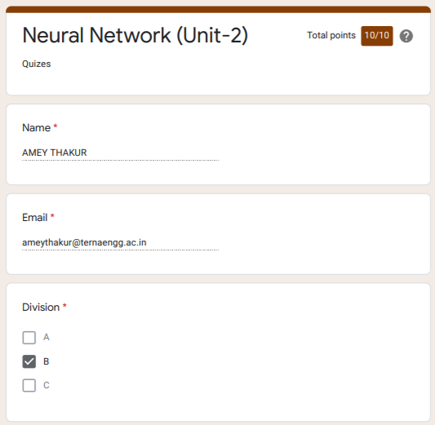

**Machine Learning Quiz 3**

**Marks: (10/10)**

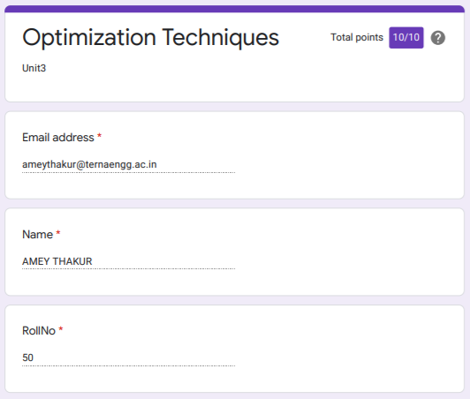

**Machine Learning Quiz 4**

**Marks: (10/10)**

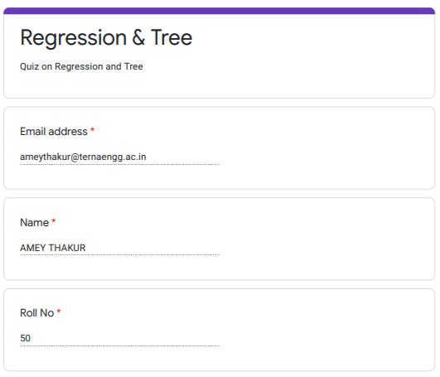

**Machine Learning Quiz 5**

**Marks: (10/10)**

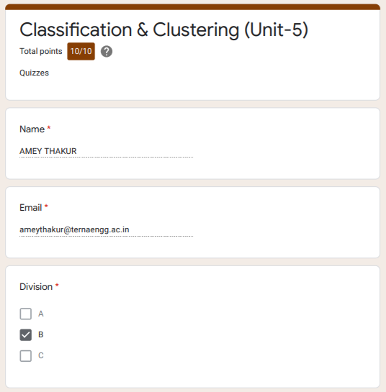

**Machine Learning Quiz 6**

**Marks: (10/10)**

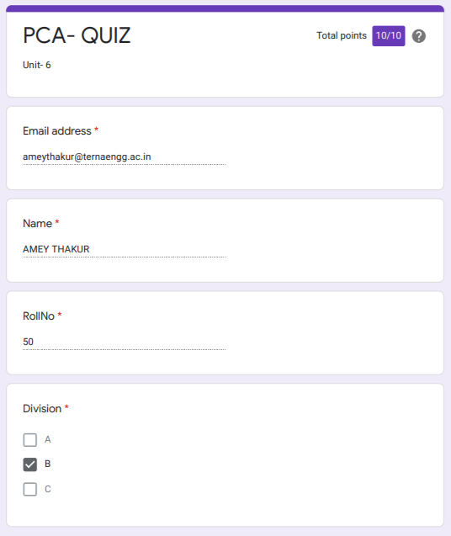

**IAT**

**Machine Learning IAT 1**

**Marks: (17/20)**

**IAT 1 Descriptive Answer Sheet**

**(First page attached)**

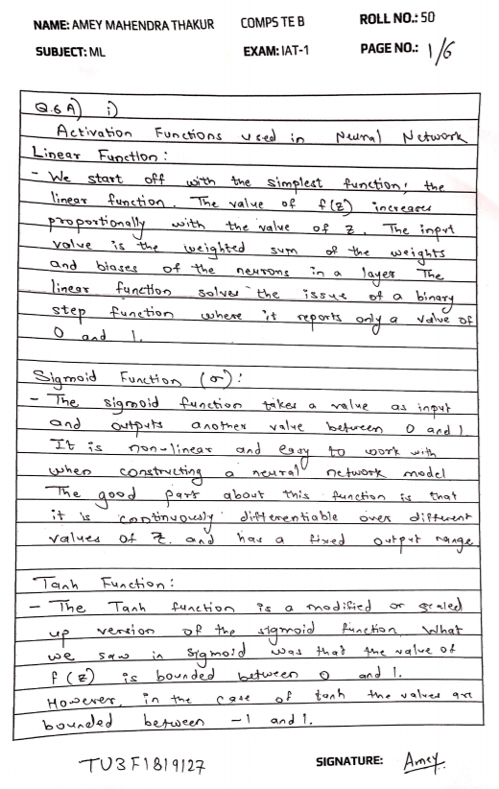

**Machine Learning IAT 2**

**Marks: Not Received**

**IAT 2 Descriptive Answer Sheet**

**(First page attached)**

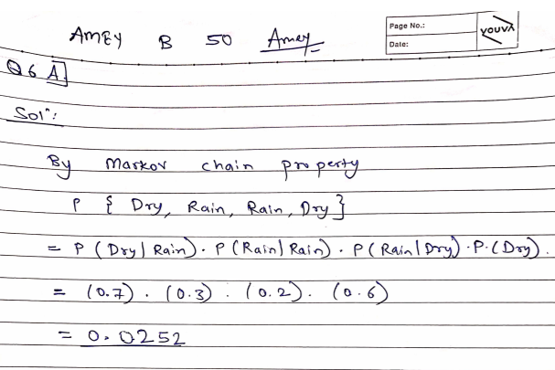

**Exit Survey**

**Machine Learning Course Exit survey**

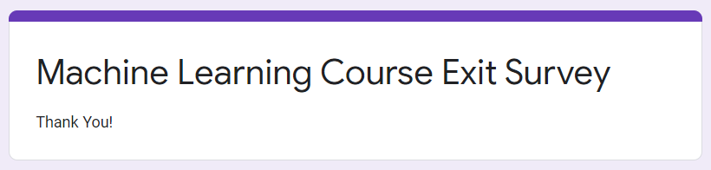

**Google Classroom Submission Report**

